**A Project ON**

## **Instagram Clone**

**“White Label Social media Web App”**

For partial fulfilment of

Bachelor of Business Administration (Computer Application)

### Submitted by

**Daudibohra mufaddal Mahammad Bhai**

Under the Guidance Of

**Mrs Ashwini ma’am**

In the Academic Year 2020-2021

**Index**

|  |  |  |
| --- | --- | --- |
| Sr. No | Content | Page No |
| 1 | Acknowledgement | 2 |
| 2 | Abstract | 3 |
| 3 | Introduction | 4 |
| 4 | Project Description | 4 |
| 5 | Existing System | 5 |
| 6 | Proposed System | 5 |
| 7 | Application and Aims | 6 |
| 8 | Project Features | 7 |
| 9 | Requirement Analysis | 7 |
| 10 | Scope of the System | 7 |
| 11 | Feasibility Studies | 8-10 |
| 12 | Security Requirements | 10-12 |
| 13 | Data Dictionary | 12-14 |
| 14 | ER Diagram | 15 |
| 15 | Data Flow Diagrams | 16 & 17 |
| 16 | User Interface(Screen Shots) | 18-22 |
| 17 | Software/Hardware Requirements | 22 & 23 |
| 18 | System Testing | 23 |
| 19 | Testing Objectives | 24 |
| 20 | Conclusion | 25 |
| 21 | Future Enhancement | 25 |
| 22 | Future Scope | 25 |
| 23 | References and Bibliography | 26 |

###### 

###### **Acknowledgement**

In successfully completing this project, many people have helped me. I would like to thank all those who are related to this project.

Primarily, I would thank Allah for being able to complete this project with success. Then I will thank my HOD Mrs Alfiya J. and Mrs Ashwini Maam, under whose guidance I learned a lot about this project. His suggestions and directions have helped in the completion of this project.

Finally, I would like to thank my parents and friends who have helped me with their valuable suggestions and guidance and have been very helpful in various stages of project completion.

###### 

###### **Abstract**

**Instagram Clone** is a web-based application intended for People Who want to share there skills and personal experience with others. The main objective of this application is to make it interactive and easy to use for people. It would make searching other people, viewing friends posts like that post and share it with others and stage to share there opinions to Others. It contains a sophisticated search engine for the user's to search for specific friend whom they want to talk with. The search engine provides an easy and convenient way to search for people where a user can search for a other people and the search engine would refine the specific people based on the user’s input. The user can Chat with tham. They can also view the other friend posts and also write their own thoughts in Comments. The application also provides a drag and drop feature so that a user can add own Pictures and etc.. to the app by dragging the item into the post add section. The main emphasis lies in providing a userfriendly search engine for effectively showing the desired results and its drag and drop behaviour.

**Introduction**

**Instagram Clone** is the way of Expressing Himself. Social Media gives the common man a platform to voice with complete freedom of expression, be it for supporting a cause or for addressing a national or international issue of any sensitivity. Business prospects and job opportunities gear up as social media is a stage with global audience to showcase our talents.

Social media started off as a trend among youth but today it has emerged as a medium that influences even Presidential elections.

What is a **Instagram Clone** and How does it Work?

Instagram is a social media app that has grown immensely over the years, and it continues to broaden its horizons. The photo-sharing app has gone a long way from once being a favorite for vacationers sharing their holiday pictures to now appealing to all kinds of influencers, advertisers, and brands.

The early version of Instagram was a html prototype for photo-sharing. But as time progressed, a bundle of languages were used to create this awesome clutter free app.

Through this project, I’ll Show basic functional clone of Instagram, relying on React.JS and Firebase.

# **Project Description**

**Instagram Clone** is a web application that matches people to another people a communication network in which a host system communicates with the user-1 to User-2. The host system obtains and stores all of the records of each corresponding to a particular user. This set of data can then be searched by a remote data terminal associated with all other users. User can post there picture and share with other friends and family members , The idea use case of this project is to help peoples to interact with others, faster and with user friendly interface

Further, the system helps to saw there post globally when they want . It’s a system for selectively displaying post , the user own profile interface is looks great with all activities and information displayed.

##### **Existing System:-**

The existing system is you have to go out and meet specifically on specific time or date and its time consuming prosses due to that people tend to not talk with others.

On the other side people are not able spread or share there thoughts, opinions ,skills , arts , and thought to others , on a specific state or any city what’s happing we didn’t got quick information, other things like stock market we have to wait for next tv news or next day newspaper to make strategic investments , people have limited area to do business and many more problems

##### **Proposed System:-**

**Instagram Clone** is a web application that Solve This problems it Build a communication between User to User or many User to many users in groups

Instagram Clone Provide Platform To showcase Things Like Skills , Thoughts, opinions , Business Ideas , job Interview , knowledge , facts , news , entertainment Things like movie , sort Film , videos , funny video etc.. , and many more use Case. Instagram Clone take User Information Like name username that they want to show to the world , password for security, profile photo , also give chance to tell others about him/her in his bio , platform That help to meet with other friends that leave in another country.

To talk with your friend who’s leaving in another country or state or maybe an another city it is too handy to use and no worries to Personal security Instagram Clone will maintain your security , only who’s can able to watch or see your post or anything you have share who’s are following him/her .

The system includes One user:

General User

Can Post Ad Can Chat with Other Users Can Follow Other Users

The user gets into the system using a username , email and a unique password , or user Google fast Signin Method.

Each user has his own accessibility permission to accomplish his task flawlessly. This is an Open System for all no one can eye one anyone .

**Advantages of the proposed system are**

1. Easy access to the data.
2. The new system is more user friendly, reliable and flexible.
3. Chat menus is user Friendly and easy to understand.
4. easy To Share photos and other stuffs.
5. Timely Report generation.

**Application (Aims & Objectives)**

**The objective of the Instagram Clone**

The project's goal is to Building a Social Media web application Using React.js And Firebase , Inspired by Original Instagram own By Facebook Today!

Another Goal of this project is to represent my web development skills like building Chat module , post module , firebase Auth providers , etc…

**Applications**

* This system can be used by Any person in the world.
* You can talk with friends share pictures opinions.
* To provide a hassle-free and fast interactive user interface to communicate with each other in the world.

**Instagram Clone features:-**

* Provides a complete online web-based Communication, including rich user interface, business Dealing, or User profile, and storing of Everything online include chat and photos.
* User can view Post from anywhere in the World 24X7, Also Ad a comment on that post and share opinions to Other Users.
* Provide a better understanding between One User To another User.

**Requirement Analysis**

At the heart of the system, analysis is a detailed understanding of all important facets of the business area under investigation. (For this reason, the process of acquiring this is often termed the detailed investigation) Analysts, working closely with the employees and managers, must study the business process to answer these key questions:

* What is being done?
* How is it being done?
* How frequently does it occur?
* How great is the volume of transactions or decisions?
* How well is the task being performed?
* Does a problem exist?
* If a problem exists, how serious is it?
* If a problem exists, what is the underlying cause?

Requirement analysis relies on fact-finding techniques. These include

* Interview
* Questionnaires
* Record inspection
* On-site observation

##### **Scope of the System:-**

1. Instagram Clone offer you the advantage of represent Your Skills and capabilities. Which makes it a better choice for fun as well as business purposes. When the User Post picture , then other people who’s are Following him/her can see That post and like it , share it , comment on it , bookmark it .
2. With this advantage, Instagram is use Widely. And if any user is interested in the advertisement then they can contact the advertisement publisher directly with the source of that Bussiness Account. With this procedure, it becomes easy for users to interact with the Other Users.
3. It is the simplest thing we can do and this is really effective. To find the best results, you should post and Share with others.

**Feasibility Study:-**

A feasibility study is conducted once the problem is clearly understood. A feasibility study is a high-level capsule version of the entire system analysis and design process. The objective is to determine quickly at a minimum expense how to solve a problem. The purpose of feasibility is not to solve the problem but to determine if the problem is worth solving.

The system has been tested for feasibility in the following points.

* Economic Feasibility.
* Technical Feasibility.
* Operational Feasibility.

**Economical Feasibility:-**

It looks at the financial aspects of the project. It determines whether the management has enough resources and budget to invest in the proposed system and the estimated time for the recovery of cost incurred. It also determines whether it is worthwhile to invest the money in the proposed project. Economic feasibility is determined by the means of cost-benefit analysis. The proposed system is economically feasible because the cost involved in purchasing the hardware and the software are approachable. The personal cost like the salaries of employees hired is also nominal because working in this system need not required a highly qualified professional. The operating-environment costs are marginal. The less time involved also helped in its economical feasibility. It was observed that the organization has already used computers for another purpose so there is no additional cost to be incurred for adding this system to its computers.

The backend required for storing other details is also the same database that is SQL. The computers in the organization are highly sophisticated and don’t need extra components to load the software. Hence the organization can implement the new system without any additional expenditure. Hence, it is economically feasible.

**Technical Feasibility:-**

It is a measure of the practicality of a specific technical solution and the availability of technical resources and expertise

* The proposed system uses HTML, CSS, and JS as the front-end and Firestore from Firebase , Node.js as the back-end tool.
* Firebase is a popular (Provide By Google) tool used to design and develop database objects such as table views, and indexes.
* The above tools are readily available, easy to work with and widely used for developing Social , commercial applications.
* This Web Application Is Build On React.JS Framework it’s a Javascript Framework Widely Use by Developer around The World

Hardware used in this project is- Ryzen 3 3.6GHz,8GB Ram, 240GB SSD. This hardware was already available on the existing computer system. The software like Firebase and JavaScript With Node.js operating system WINDOWS 11 used were already installed On the existing computer system. So no additional hardware and software were required to purchase and it is technically feasible. The technical feasibility is in employing computers in the organization. The organization is equipped with enough computers so that it is easier for updating. Hence the organization has no technical difficulty in adding this system.

Tools Used:

Firebase Authentication , Javascript, Firebase FireStore ( Database) , BootStrap v5, vs code Ide.

**Operational feasibility:-**

The system will be used if it is developed well and then be resistant to users that are undetermined

* No major training and new skills are required as it is based on the DBMS model.
* It will help in the time saving and fast processing and dispersal of user requests and applications.
* The new product will provide all the benefits of the present system with better performance.
* Improved information, better management and collection of the reports.
* User involvement in the building of the present system is sought to keep in mind the user-specific requirement and needs.
* Users will have control over their own information. Important information such as Personal Posts, account are safe.
* The faster and systematic processing of user Account, Chat IDs, Posts etc. used had greater chances of error due to wrong information entered by mistake.

##### **Security Requirements:-**

One might think that there is little reason to be concerned about security in an intranet. After all, by definition an intranet is internal to one’s organization; outsiders can not access it. There are strong arguments for the position that an intranet should be completely open to its users, with little or no security. One might not have considered one’s intranet in any other light.

On the other hand, implementing some simple, built-in security measures in one’s intranet can allow one to provide resources one might not have considered possible in such a context. For example, one can give access to some Web Pages to some people without them being available to oner entire customer base, with several kinds of authentication.

There are basically two types of security associated with this system:

**1. Physical security:-** Damage due to natural causes like an earth tremor, flooding, waterlogging, fire hazards, atmospheric or environmental conditions etc. For overcoming these difficulties the replica of the data is automatically stored at various networks and for environmental conditions, and Air conditioning environment is created.

**2. Data security:-**

There are basically two problems associated with data security:-

a). Data not being available to the authorized person at the time of need.

b). Data becoming available to unauthorized persons.

To overcome these difficulties the following access facilities have been provided:-

* ***Identification:-*** Unique Ids for the different users have been provided. With Auth Token So every time thay log in they don’t need to re-login again and again
* ***Authentication:-*** System checks the password under the particular user identification. The computer permits the various resource to the authorized person. And Via Google Authentication Security issues Handle by Google
* ***Authorisation:-*** The access control mechanism to prevent unauthorized logging into the system.

**Data Dictionary:-**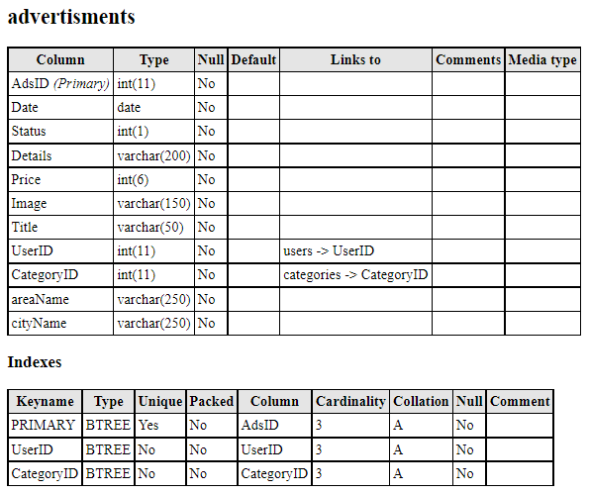

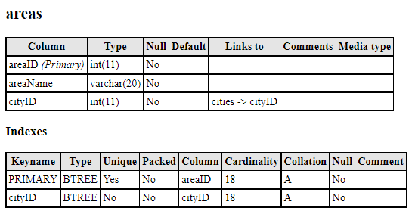

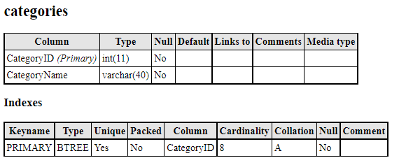

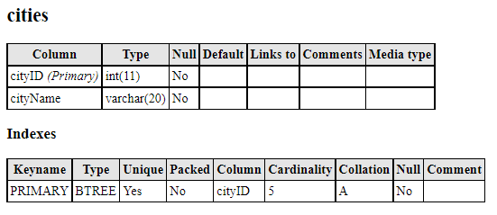

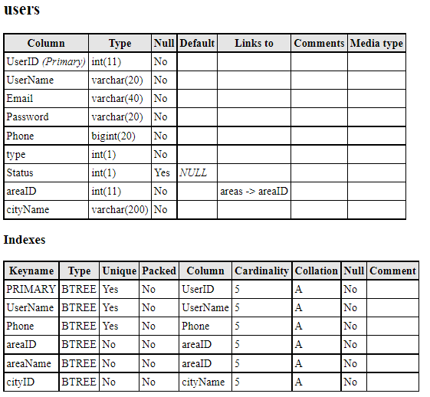

**Software Used In this Project**

**Instagram Clone** in React.js

**Front end**: HTML, CSS, JavaScript with React Framework

* HTML: HTML is used to create and save web documents.
* CSS: (Cascading Style Sheets) Create an attractive Layout
* Bootstrap: Responsive design of the mobile-friendly website
* JavaScript: It is a programming language, commonly used with web browsers.
* React: it is an Framework which provide fast development and handy tools like Contaxt Api , Redux , React Hooks , State Prop management etc…

**Back end**: Firebase, FireStore ( Database)

* Firebase: Firebase is a technology that Help Developers To Build Web app, mobile app, desktop app With rich features like auth , Hosting , Database etc..
* FireStore: FireStore is a database, used for Faster Comunication querying, updating, and managing data in databases
* Firebase Auth: it Provide Authentication with on tap auth like google Sign in or Sign up

**Modules In Instagram Clone:-**

* **Chat Module**
* **Login Process**
* **Registration Process**
* **Following / Followers Module**
* **Logout**
* **Post Module**
* **Comments On Post module**

**ER Diagram:-**

An entity-relationship diagram (ERD), also known as an entity-relationship model, is a graphical representation that depicts relationships among people, objects, places, concepts or events within an information technology (IT) system. An ERD usesdata modelling techniques that can help define business processes and serve as the foundation for a relational database.

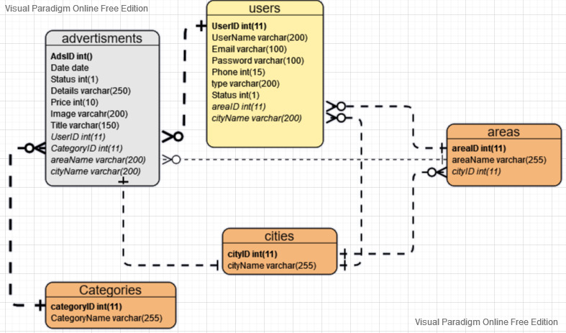

**Database Tables**

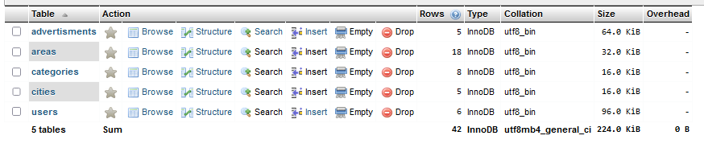

**Data Flow Diagrams:**

Data Flow Diagramming is a means of representing a system at any level of detail with a graphic network of symbols showing data flows, data stores, data processes, and data sources/destinations.

The data flow diagram is analogous to a road map. It is a network model of all possibilities with different detail shown on different hierarchical levels. This process of representing different details level is called “levelling” or “partitioning” by some data flow diagram advocates. Like a road map, there is no starting point or stop point, no time or timing, or steps to get somewhere. We just know that the data path must exist because at some point it will be needed. A road map shows all existing or planned roads because the road is needed.

**DFD 0-Level**

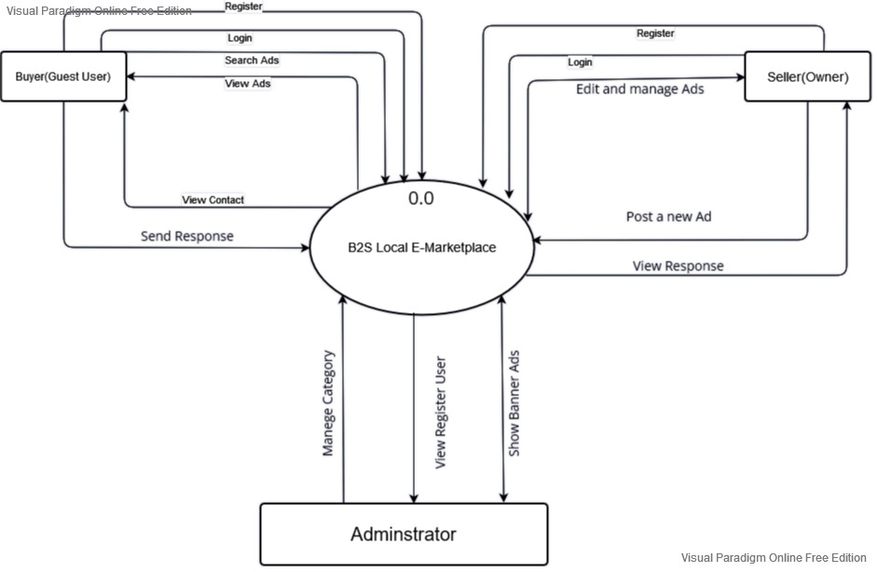

**DFD 1-Level:**

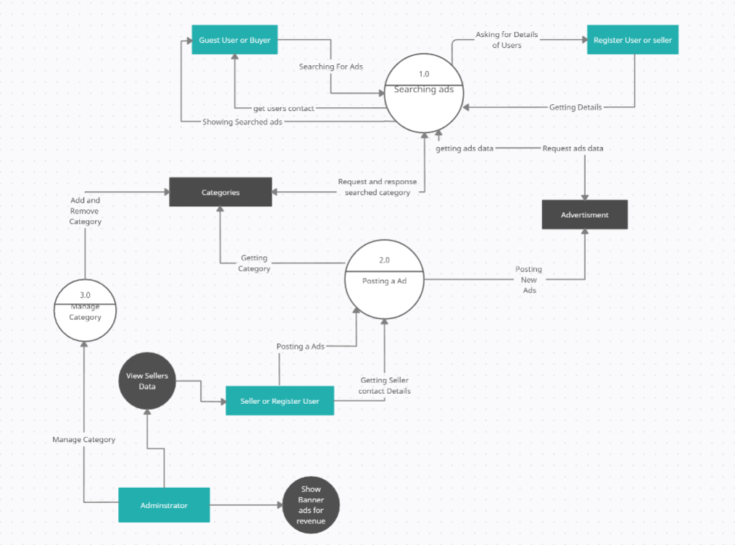

**User Interface Of B2S-Local E-Marketplace**

**ScreenShots**

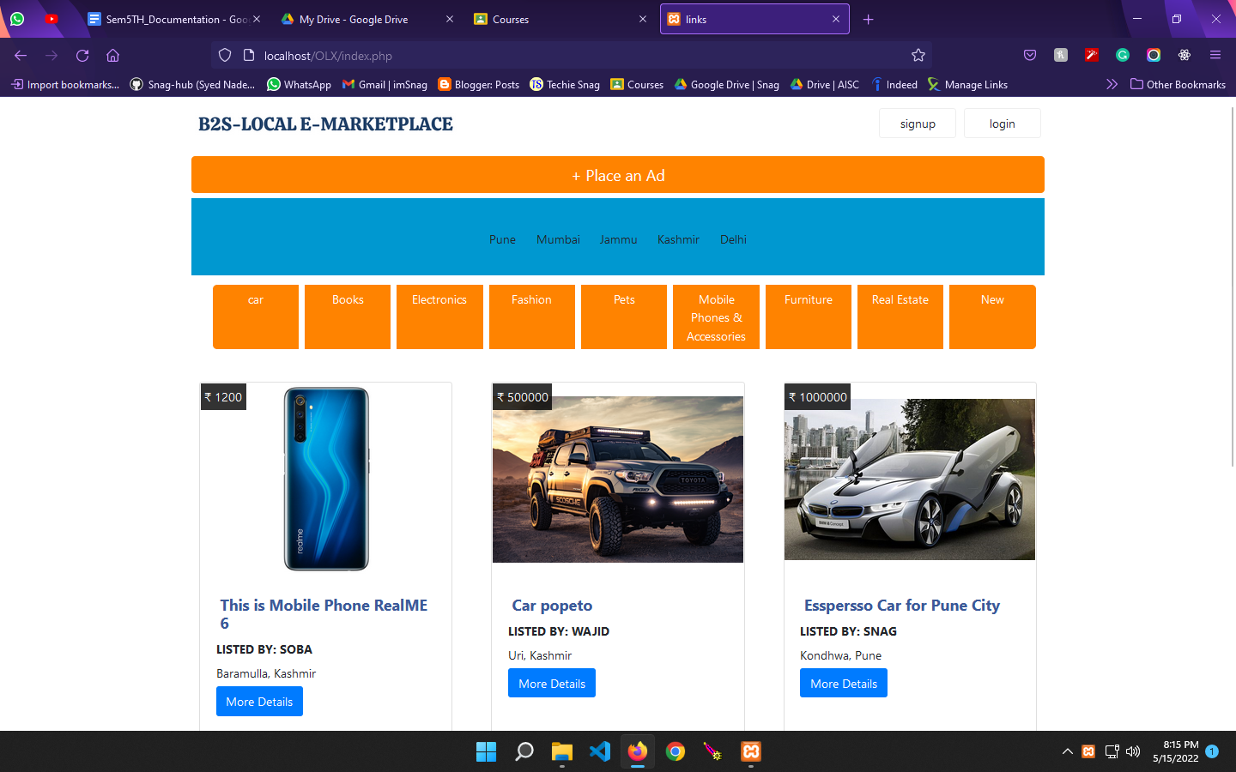

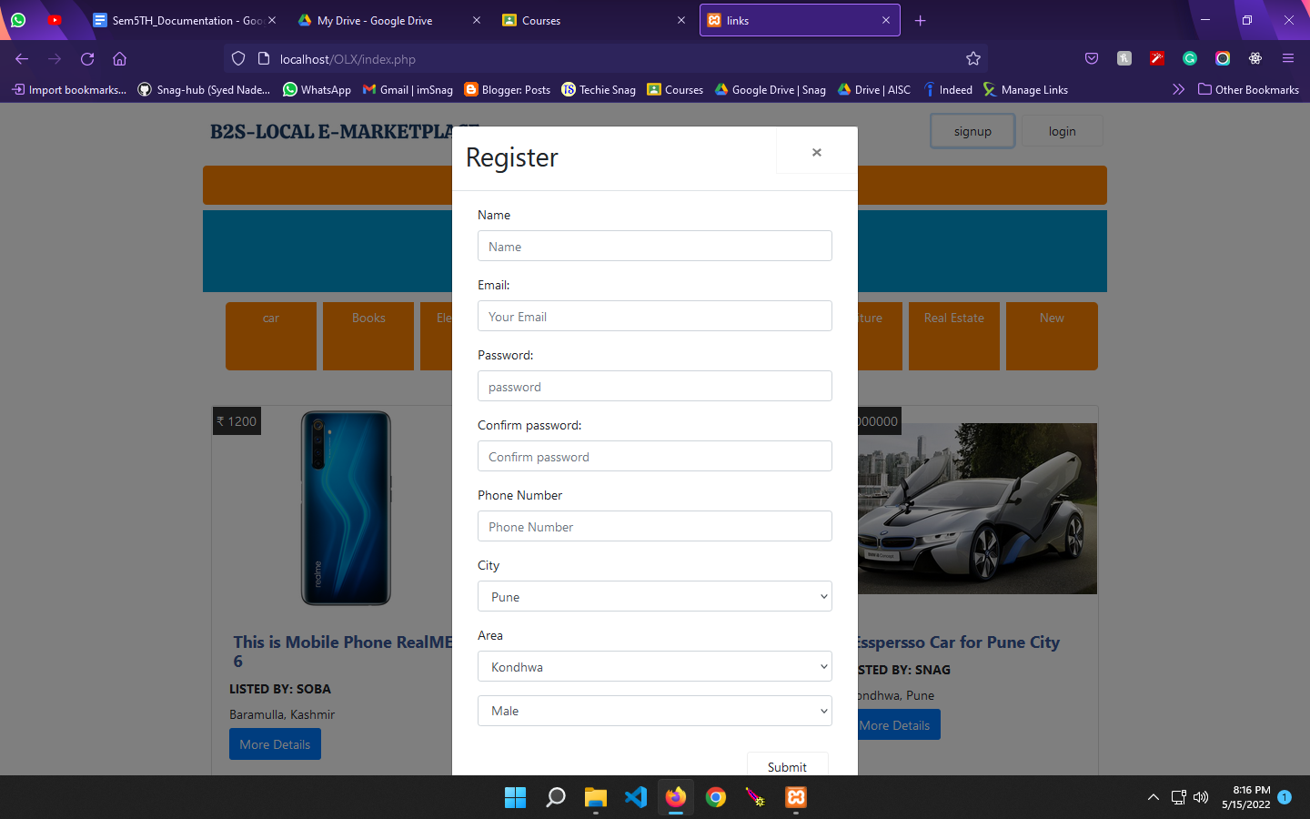

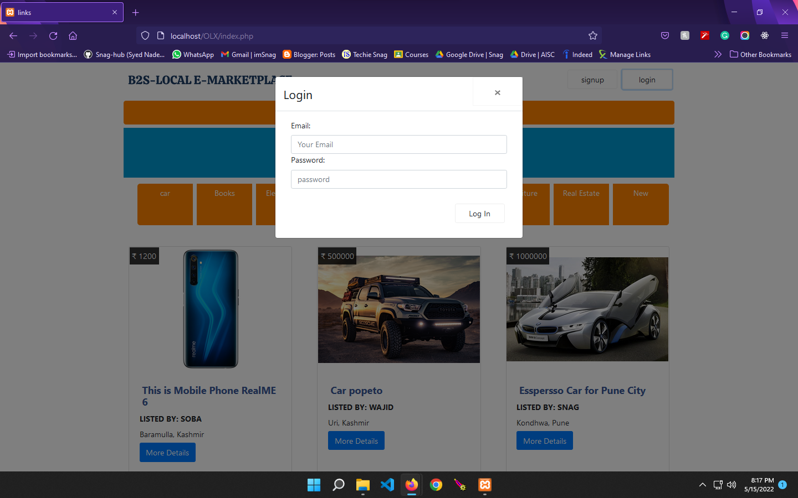

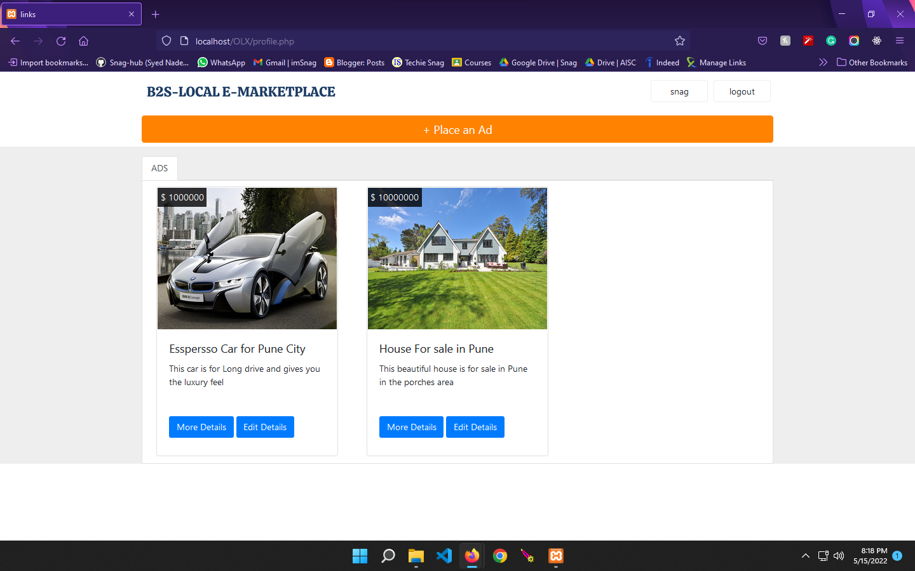

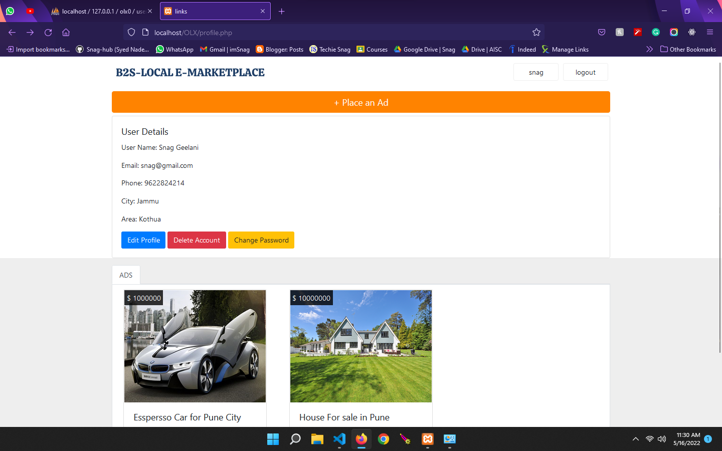

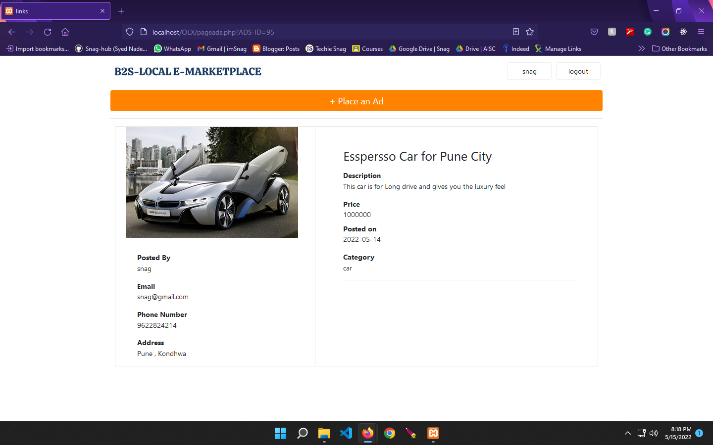

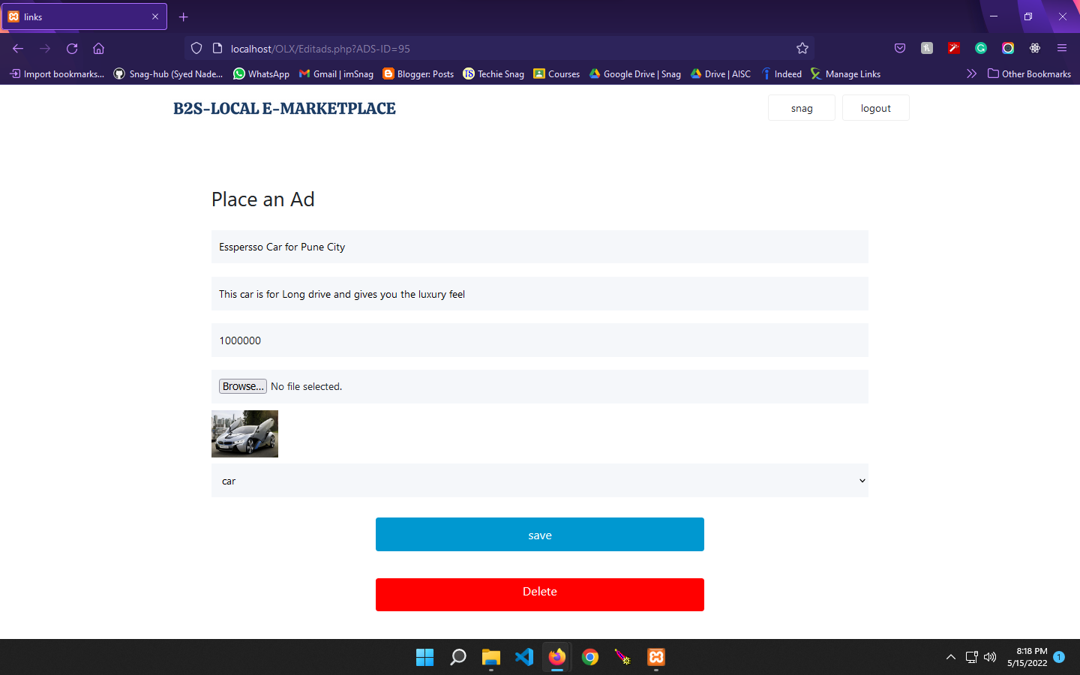

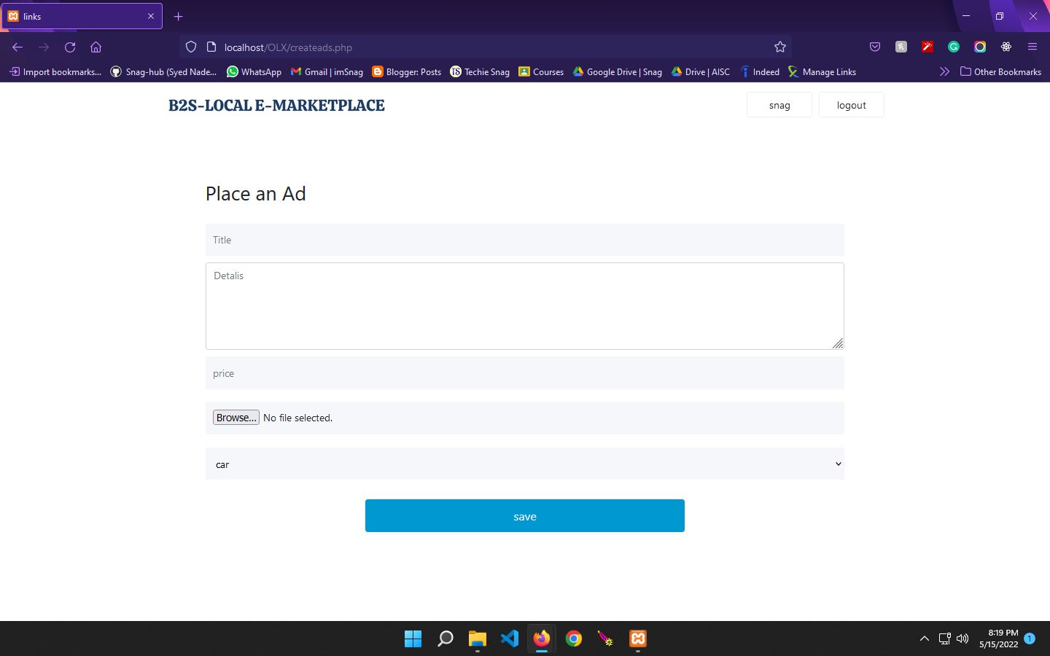

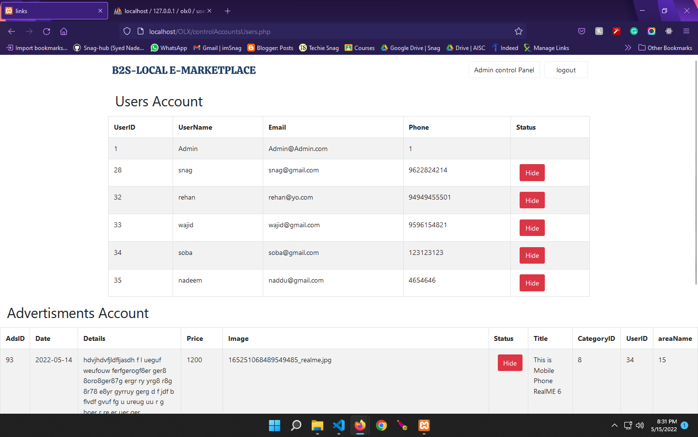

**Software Requirements**

* Windows 7(ultimate, enterprise), Windows 8, Windows 10 and 11.
* VS Code 2015 Onward
* PHP 8.0.12.
* HTML 5, CSS 3, JS ECMAScript 2021.
* Bootstrap 4

**Hardware Requirements**

***Minimum requirement***

* Processor – Intel I3 Onward
* Hard Disk – 0 GB
* Memory – 512MB RAM
* Internet
* Internet Explorer (Google Crome/safari/edge/firefox)

##### **System Testing:-**

Here the System testing involved is the most widely used testing process consisting of five stages as shown in the figure. In general, the sequence of testing activities is component testing, integration testing, and then user testing. However, as defects are discovered at any one stage, they require program modifications to correct them and this may require other stages in the testing process to be repeated.

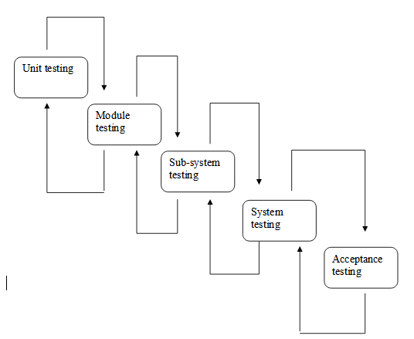

**(Component testing) (Integration testing) (User testing**)

Testing is the process of detecting errors. Testing performs a very critical role in quality assurance and in ensuring the reliability of the software. The results of testing are used later on during maintenance also.

**TESTING OBJECTIVES:**

The main objective of testing is to uncover a host of errors, systematically and with minimum effort and time. Stating formally, we can say,

* Testing is the process of executing a program with the intent of finding an error.
* A successful test is one that uncovers an as yet undiscovered error.
* A good test case is one that has a high probability of finding an error if it exists.
* The tests are inadequate to detect possibly present errors.
* The software more or less conforms to the quality and reliability standards.

#### **Conclusion:-**

As evidence of the success of this mission, there are millions of Post listed each day via thousands of different Accounts. There are multiple features , and chat system , post , comment And the variety doesn’t stop there. Want to Become an Influencer ? Join Instagram Plateform, Build Your own Community that follow your hear you ,What Friends and Family? There are Groups That Build for multi purpose, like Bussiness Groups for business improvement, Friends, College , Colleagues, Office , Private , party Groups End less Things are there spending time by gathering Knowledge From Social media Is valuable .

Original Instagram Is Soo powerful That handle millions of User I have take Huge References From Original Instagram To Represent My Project

In this instance, it may be true that eBay, they have something for everybody, whatever their tastes may be.

# **Future Enhancement:-**

Since this system has been generated by using Object Oriented programming, and Framework like react.js there are many chances of reusability of the codes in another environment even on different platforms. Also, its present features can be enhanced by some simple modifications in the codes so as to reuse them in the changing scenario.

The site is made in all possible ways to meet the user requirements using the latest version of available software and hardware. But as user requirements and operating environment keep changing further extensions can be made on this.

**Limitations:-**

Since every system has some limitations so our proposed system is also not untouchable in this regard. Although it includes every kind of feature, it can’t be used in a huge organization where the number of networks is very large, because the database used in this system is an average one. Also, it doesn’t have different kinds of access features for different users.

Though it was planned for this system to be absolutely perfect everything as such has some limitations, and so does the System. Following may be the drawback of this system.

* Though this system is developed as a multi-user system it is not right now optimal to handle thousands of user.
* The interaction with the database, every time they are loaded thus the system tends to be a bit slow.

#### **Future Scope:-**

* Providing the Notification alerts facility to users to Get notified when any friend post a picture or comment on his/her picture or like his/her post.
* Providing More handy features like reply on comments that posted review and share in the form of Blogs, Photos, Videos, and discussions in multiple explosively popular areas of interest such as Movies, Travel, events and much more.
* Explore Options like seeing other open accounts videos
* Smart user finding search engine, optimal Chat system
* Emojis and many more

## Bibliography and References:-

[React – A JavaScript library for building user interfaces (reactjs.org)](https://reactjs.org/)

[www.getbootstrap.com/docs/4.0](http://www.getbootstrap.com/docs/4.0/getting-started/introduction/) [www.wikipedia.org](http://www.wikipedia.org/)

[www.w3schools.com](http://www.w3schools.com/) [www.html.com](http://www.html.com/)

[www.stackoverflow.com](http://www.stackoverflow.com) <https://github.com/> [www.scribd.com](http://www.scribd.com)